**Hospital Management System for Mayo Clinic**



**Submitted by:**

Mohit Pal

Table of Contents

1- Introduction 3

1.1- Business Analysis Core Concept Model (BACCM) 3

1.2- Requirement Classification Schema (RCS) 4

2- Identify stakeholders 6

3- The proposed system workflow 7

4- The In-scope and Out of Scope Items for HMS 7

5- Finding the Scope of Hospital Management System (HMS) (Context Diagram) 8

6- Main features of HMS 9

7- ER diagram of the system 10

8- How data will flow in HMS 11

9- Key functional and Non-functional requirements 12

10- Flow chart for the patient’s admission procedure 13

11- Wireframe for Home page and Patients registration 14

# 1- Introduction

The Mayo Clinic is an American non-profit academic medical center currently based in three major locations, Rochester, Minnesota; Jacksonville, Florida; and Scottsdale, Arizona focused on integrated patient care, education, and research. Mayo Clinic holds the number 1 rank among hospitals in the United States. It was opened on the 30th of September 1889. Over the years it grew in size and facilities. It increased the size of its premises and also the number of doctors it employs. The vast number of patients it treated made the management of such a huge hospital an arduous task. The paperwork and storing of all patients’ records was becoming unmanageable. It was then the management of the hospital decided to invest money in hospital management software. The Hospital Management System is designed to manage all hospital operations. The 1980s initiated transformative changes that set the course for the modern Mayo Clinic. As an early adopter of the Internet, Mayo Clinic has been recognized for its online communications to patients.

## 1.1- Business Analysis Core Concept Model (BACCM)

## 1.2- Requirement Classification Schema (RCS)

1. **Business Requirements:** To develop a Hospital Management System (HMS) to manage all the hospital operations which can help the patients to book online appointments and track their medical records.

* Reducing operating costs of the hospital.
* Provides reports to senior management for decision-making.
* Save Patient time by keeping medical records stored in the cloud.
* Keeps track of Empty and occupied beds in the hospital.
* Reduced paperwork and documentation in the hospital.

1. **Stakeholder Requirements:** The key stakeholders are Patients, Hospital staff, and management.

* **Patients:** Patients being the users of HMS should be able to book online appointments and able to access their medical records and get reminders for their appointments.
* **Hospital staff and management:**
* **Doctors and nurses:** As the hospital staff the doctors and nurses should be able to access the data in order to check medical history and suggest medication.
* **Registration and billing staff:** The registration staff should be able to use the system easily in order to register the patient and assist the billing team with bill processing.
* **Laboratory staff:** The laboratory staff should have access in order to track and provide reports for the prescribed tests of the patient assisting the doctor, patients, and billing team accordingly.
* **Senior Management:** The system is to be designed in a way that it provides appropriate reports to the senior management that assist in the decision-making process.

1. **Solution Requirements:**

* **Functional Requirements:**
* Patient registration and appointment management
* Appointment reminders
* Bed occupancy
* Billing assistance
* Laboratory, blood bank, and radiation department assistance and management
* Staff management
* Instructions for patients
* Insurance Details
* Reports for management decision making
* **Non Functional Requirements:**
* MYSQL database to be used since it is open source and free.
* The operating system should be Windows 2016
* The system should be and web-based application
* This system shall respond within 1 second
* The system shall keep all the logs for errors
* This system should be scalable to 500 users at a time
* The screen should be self-explanatory and user-friendly.

1. **Transition Requirement:** The users of this system should be trained enough to use it efficiently. As there will be reduced or no paperwork involved in the process every user should have access to the system through portable devices (Mobile, tablets, laptop, etc).

# 2- Identify stakeholders

RACI matrix is used here for identifying the responsibility of each stakeholder involved in the process:

Responsible (R): The individuals who will be performing the work on the task.

Accountable (A): The individual who is ultimately answerable for the completion of the task and is the decision maker.

Consulted (C): The stakeholder (group) who will be asked to provide opinion or information about the task.

Informed (I): The stakeholder (group) that is kept up to date on the task and its outcome.

|  |  |  |  |  |
| --- | --- | --- | --- | --- |
| **Stakeholders** | **Responsible** | **Accountable** | **Consulted** | **Informed** |
| Project Manager |  | A |  |  |
| Developer | R |  |  |  |
| Tester | R |  |  |  |
| Domain SME |  |  | C |  |
| Operational Support |  |  | C |  |
| Implementation SME | R |  |  |  |
| Business Analyst | R |  |  |  |
| Hospital Staff |  |  |  | I |
| Patients |  |  |  | I |
| Supplier |  |  |  | I |
| Regulators |  |  | C |  |

# 3- The proposed system workflow

# 4- The In-scope and Out of Scope Items for HMS

|  |  |
| --- | --- |
| **In-Scope Requirements** | **Out-of-Scope Requirements** |
| Online appointment Scheduling | Only for registered users |
| Appointment Reminders | Appointment reminders only to existing Users |
| Patients Registration | Registration must be completed |
| Add / Update medical records | Only after consultation with the doctor |
| Medical prescriptions | Only after a doctor prescribed |
| Lab test results | Lab test results must be updated on HMS |
| Bed Occupancy | Should be more than no. of beds in the clinic |
| Hospital staff management | Only Mayo Clinic staff management |
| Billing and Reports generation | Billing must be generated at the end |

# 5- Finding the Scope of Hospital Management System (HMS) (Context Diagram)

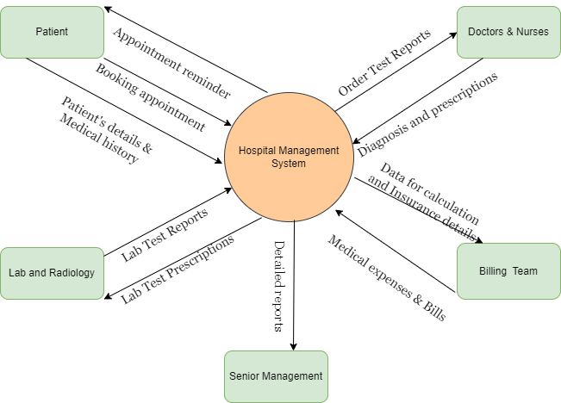

# 6- Main features of HMS

1. Web-based Management System

* Must have MYSQL database and operate with Windows 2016
* Must support a volume of at least 500 users at a time
* Must respond within 1 second
* Must be interactive and user-friendly
* Must be working all the times

1. Patient Registration and Login
2. Appointment reminders via Email or SMS
3. Schedule/ Reschedule/ cancel appointment
4. Store patient's medical records for anytime access
5. Staff allocation
6. Vacant and allocated bed details
7. Bill generation
8. Patient’s insurance details
9. Reports for Senior management

* Bed occupancy for each day
* Doctor’s appointment and revenue generation through OPDs
* Total number of OPD and admitted patients
* Which doctor generates the maximum revenue
* Total amount of earnings through OPDs and admitted patients
* Total amount of earnings through lab and radiology

# 7- ER diagram of the system

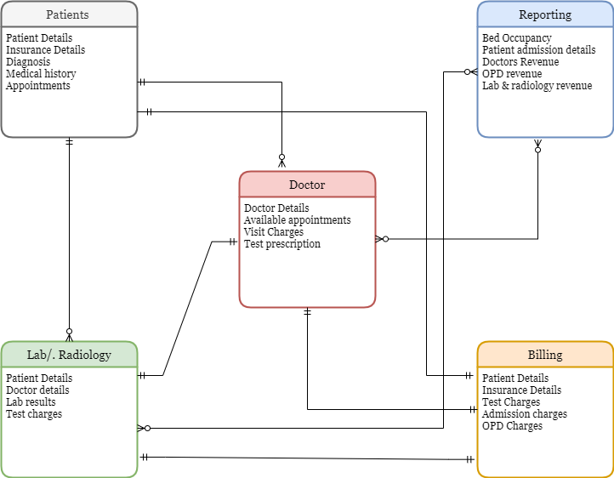

# 8- How data will flow in HMS

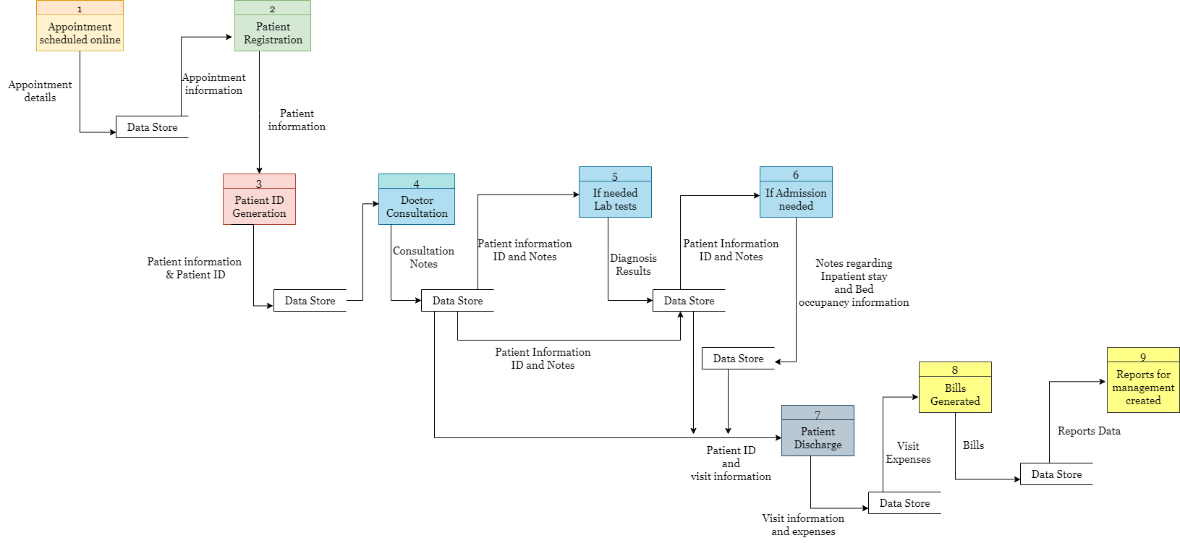

# 9- Key functional and Non-functional requirements

1. **Functional Requirements:**

* Patient registration screen
* Appointment booking and reminder
* Patient’s medical records
* Doctor’s prescription page
* Lab and radiology reports page
* Bed occupancy details portal
* Staff allocation and management
* Medical expenses and billing calculation
* Reports for senior management
* Insurance information

1. **Nonfunctional Requirements:**

* MySQL Databaseto be used since it is open source and free.
* The operating systemshall be Windows 2016
* The system shall be a web-based application.
* The system shall respond within 1 second
* The system must support 500 people using at a time
* The system shall keep logs of all the errors
* The system shall be available all the time
* The system should be self-explanatory and very user friendly.

# 10- Flow chart for the patient’s admission procedure

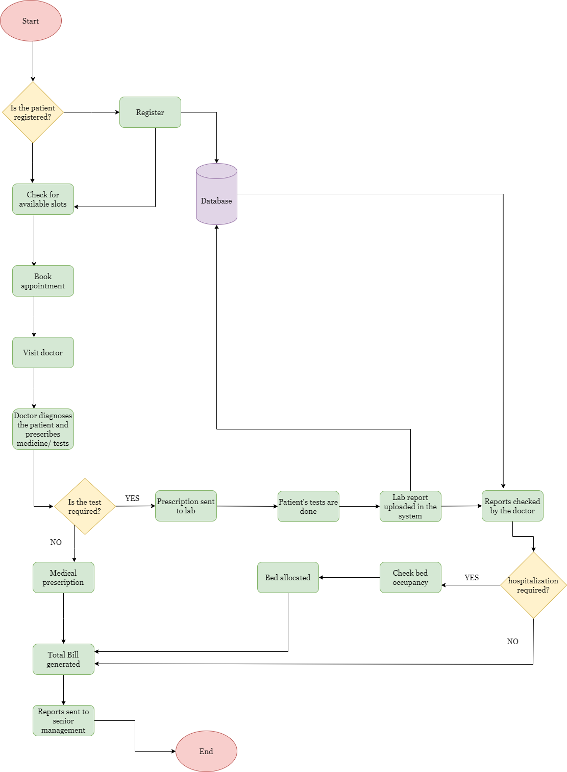

# 11- Wireframe for Home page and Patients registration

